Preparing Maps for Sharing
Introduction

Having mapping skills is great, but what do you do with your map once you have added all the necessary layers and performed your analysis? How do you prepare a map so that it looks polished and professional when you hand it out to your boss, your colleagues, or members of your community? This week we will learn about the Layout options in ArcGIS.
Important note: After this exercise, I will expect any map you make to be formatted according to these guidelines. Maps submitted without proper layouts will lose points. Presentation counts!
Let’s begin by quickly putting together a point map of your crime type and then learning about the Layout options.
Assembling a map to share

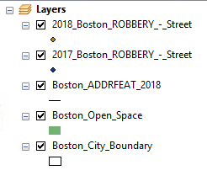
Using the files that you have already downloaded and/or created, assemble a base map of Boston (City Boundary, ADDRFEAT, Open Space) and add your 2017 and 2018 crime data – you can use separate layers or your combined layer (from the previous ArcGIS exercise), it doesn’t make much of a difference here.
Make sure that your selected map symbols are professional and easy to see and understand. For example, parks should be some shade of green, roads should be black or grey, and your crime data points should be appropriately sized and visible on top of your map.
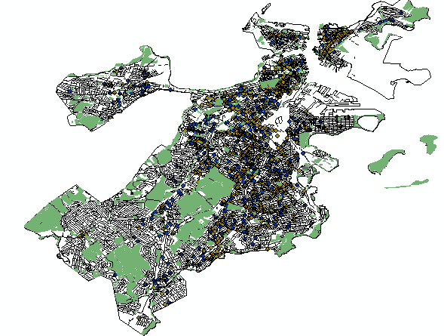
Layout View

Once you are satisfied with your point map, switch to Layout view. You can do this in two ways – using the tiny button in the bottom left corner of your map viewing frame or by using drop-down menu View (at the top of your screen) and selecting Layout View.
As you can see, switching to the Layout View places your map on what looks like a piece of paper. This is basically a “print preview,” just like you might use in Microsoft Word before you go ahead and print your document. By default, ArcGIS usually uses a plain, portrait-orientation frame.
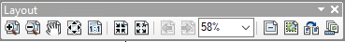
In Layout view, you should see the Layout toolbar: . If you don’t see it, don’t worry – just go to the drop-down menu Customize (at the top of your window) and select Toolbars and then Layout.

Icon | Tool Name | Function
 | Zoom In | Zoom in on the map layout (not the map itself) by clicking once or by dragging a box on the layout.
 | Zoom Out | Zoom out on the map layout (not the map itself) by clicking once or by dragging a box on the layout.
 | Pan | Pan the map layout (not the map itself) by clicking and dragging it.
 | Zoom Whole Page | Zoom to the full extent of the map layout.
 | Zoom to 100% | Zoom the map layout to 100%.
 | Fixed Zoom In/Out | Zoom in or out around the center of the map layout.
 | Zoom to Percent | Zoom the map layout by a given percentage. You can pick from the list or type in a custom percentage.
 | Toggle Draft Mode | Toggle draft mode of the frame graphics. This hides your map so that you can edit your layout without ArcGIS trying to draw the map. This could be useful if your map contains a lot of data and is slowing down your computer.
 | Focus Data Frame | Focusing on a data frame (e.g. the layout frame containing your map) allows you to work in it without editing the rest of the layout or having to switch back to Data View.
 | Change Layout | Change your layout by selecting a layout template.
 | Data Driven Pages Toolbar | This tool allows you to use the same layout to create multiple maps, e.g. if you were creating a series of maps or a map book and you wanted every map to have the same layout.

Changing layout templates and positioning your map

When you first switch into Layout View, your map will display in the middle of what looks like a plain piece of paper. The first thing you might want to do is change the orientation of that page or choose a nicer layout.
Click the Change Layout button on your layout toolbar. This will bring up the Select Template window. Across the top of this window there are tabs for different sections. Most of the templates available are for very specific types of maps or are really dated, so we’ll be creating our own custom layout. Go to the North American (ANSI) Page Sizes tab and select “Letter (ANSI A) Landscape” then click the Finish button.
Your map layout should now have a landscape (wider than it is tall) orientation. Boston is a tough city to fit in a map layout because it is really on a diagonal – the portrait layout isn’t quite right, but the landscape layout isn’t quite right either. We just have to make do! We will try to make it fit as nicely as possible.
Your map may not be well-positioned in the layout just yet. To move your map around, do not use the layout tools – these tools are for editing the layout. Instead, go up to your normal toolbar, the same one that you use when building your map, and use the tools there – the magnifying glasses to zoom in and out, and the white hand “Pan” tool to move your map around. Use these tools to move your map until you are making as much use of the layout as possible without cutting off any of your map (except the little islands off the coast – we don’t really need those for our purpose!).
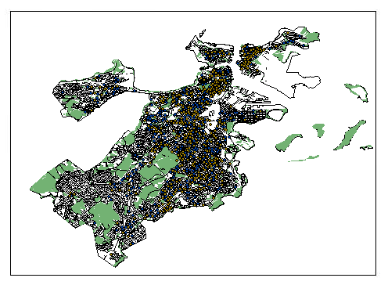
From this point, we can start adding required elements to our map layout so that it can be correctly interpreted and understood.

Adding required elements

As you learned from our Week 5 lecture and from your reading assignments, there are several required elements that must be on your map so that anyone who picks it up has the information they need to understand it and to follow up on it, e.g. by contacting the map author to give feedback.
These required elements are: Title, Legend/Key, Scale, North Arrow/Compass, Data Source, Author and Date, and Coordinate System.
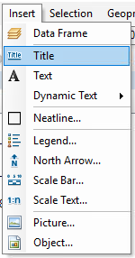
Most of these elements can be added to your map by using the drop-down Insert menu (at the top of your screen).
Let’s start with the Title. Click Insert > Title and give your map a descriptive name. I am calling my map “2017-2018 Street Robberies in Boston.” You should see your title added to your map, but you may need to carefully reposition it – remember, almost everything in the Layout view is selectable/moveable, so when working in this view you must be very, very careful to click and move the right object.
You can double-click your title and select Change Symbol… to change the font, font size, and color. I am leaving my title in the same black font, but I did increase the size so it looks like a proper title! I also moved my title to just outside the map frame, centered at the top of my page.

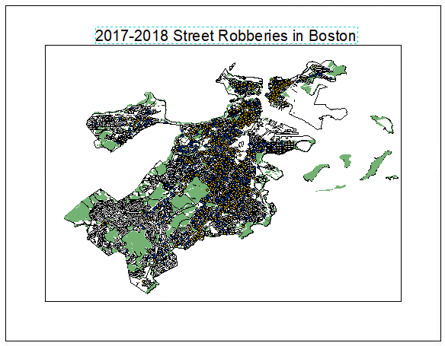

Next, a Legend or Key – the guide that tells our map reader which layers are visible on the map and what they symbolize. Go to Insert > Legend.
We have used the Legend Wizard before, but we have not yet explored all its different options. Let’s learn about them now.
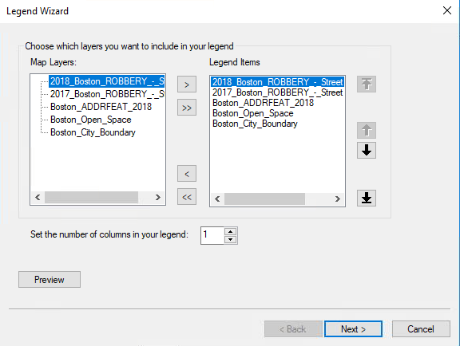
The first step in the wizard has two columns: Map Layers and Legend Items. This is where we can choose which of the layers on our map we want listed in the legend. This is nice if you have lots of different layers on your map but you don’t really need all of them explained. For example, even though our “City Boundary” layer is on the map, we don’t really need to tell our reader about it – we want them to focus on the crime data. Let’s remove the City Boundary from our legend. In the Legend Items column, click the Boston_City_Boundary layer and click the < button to take it out of the legend.
You can also reorder the items in your legend by using the up and down arrows on the right side of the window.
Click the Next> button. The next step in the wizard allows us to give our legend a different title and to change the font, font color, and size of that title. I think “Legend” is fine, so I’m just going to leave it. Click the Next> button again.
The next step of the wizard allows us to edit the Legend Frame. Here, we can add a border, a background, and a drop shadow to our legend. I don’t want to get too fancy – I want my reader looking at my map, not distracted by my legend, but I think I will make the background the Grey 10% option. Then I can click Finish.
My legend is now on my map, but I need to carefully move it into a good position so that it isn’t covering up any of my map data. I’m going to place it in the bottom right corner of my map frame (see below).
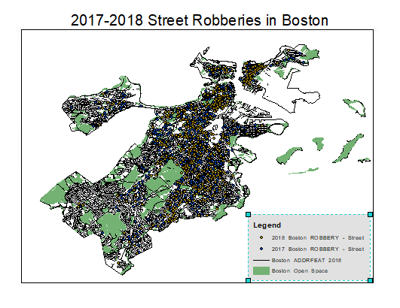
One more thing – I don’t like how my layers are named in the Legend. I don’t feel like my readers are going to see “Boston ADDRFEAT 2018” and know that those are just streets. I’d like to rename these layers so that they look more professional.
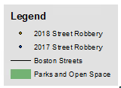
All I need to do is change the name of the layers in my Table of Contents and this legend will automatically update. For example, double-click the Boston ADDRFEAT 2018 layer in your Table of Contents to open the Layer Properties window, and under the General tab, you can change the layer name. I renamed mine to Boston Streets. I’m also going to rename my two robbery points layers to just “2017 Street Robbery” and “2018 Street Robbery.” Finally, I’ll rename the parks layer to just “Parks and Open Space.”
Starting to look pretty good! Okay, what’s next? A scale and a north arrow/compass. These two elements tell our reader how much space on the map represents how much space in real life, and which direction on our map is north (we would hope it is always the top of the map, but we don’t want to assume!).
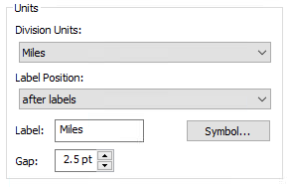
Go to Insert > Scale Bar and choose an option that you like. I’m just going to pick the first option because it is nice and plain. Click OK to insert the scale on your map, and then move it into a good position. I placed mine just outside of my map frame on the left side (see below). My scale is currently measured in decimal degrees, which I don’t think is very easy for people to understand, so I can double-click the scale to open up the Alternating Scale Bar Properties window. Under “Scale and Units”, there is a section called “Units” and I’m going to change my Division Units to Miles and then click OK.
Go to Insert > North Arrow and select a nice arrow for your map. Move it to a good location.
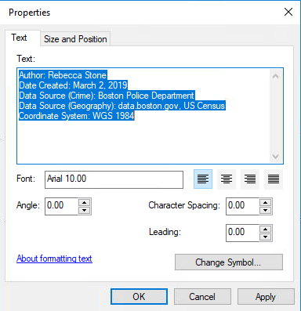
One last step: we need to add the map author and date of creation, the data source, and the coordinate system for our map. We can do this by adding a text box somewhere on the map and typing in this information. (Before doing this, check the projection system for your map by right-clicking any layer and selecting Properties > Source and looking for the Geographic Coordinate System).
Go to Insert > Text and ArcGIS will place a text box on your map. Unfortunately, it will probably drop this almost-invisible box right in the middle of your map where is hard to see. Try very carefully zooming in using your mouse wheel (to avoid clicking on the map and accidentally unselecting your new text box, in which case it will be invisible!). Once you find your text box, carefully move it to a good location – I placed mine outside of my map frame, below my legend. Double-click your text box to edit the text. See below for my final version:
