Using Mapping for Policy Analysis:
Replicating Zgoba, Levenson and McKee’s (2009) study of sex offender residence restrictions

Introduction

Before we begin: I have created a zipped folder of map layers for you that you should use in this class from here on. Ideally you would use base maps that you created earlier in semester, but because people got to different stages with those maps and some of you might be missing important data, I have assembled a library of data layers for you. Please download the zipped folder from Blackboard and copy the files inside (all of them!) into a new folder on your flash drive. You can call it something like “Dr Stone’s Map Layers.”

In this folder you will find the following layers: Boston city boundary; census tracts, blocks, and block groups; Boston neighborhoods; police districts; Boston addrfeat (the address range features layer – looks like streets, can be used to create address locators); water and open space; Boston public schools; Boston police stations; level 2 & 3 registered sex offenders’ MBTA bus stops and T stations. I have also put all of our Boston crime data spreadsheets in the folder.

The zipped folder is available for download in the Project Guidelines and Resources folder on Blackboard.

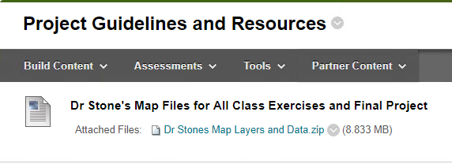
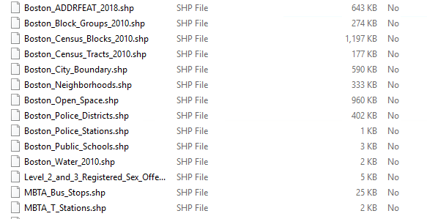
Do we have the necessary map layers?

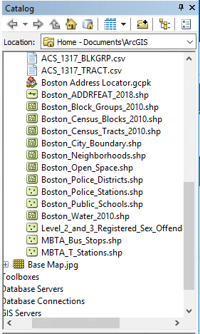
Let’s reflect on what Zgoba and her colleagues did in their study. They had a base map of Camden County, New Jersey. They had a list of 211 registered Level 2 and 3 sex offenders, which they pulled from the public registry. Then they got lists of addresses for all private and public schools, day care centers, parks, and churches. They geocoded all their lists of addresses to add them as layers to their map of Camden County.

We’ll skip the private schools, day care centers, parks, and churches, and just focus on public schools. So which data layers will we need to replicate the study, and what do you see in your folder?

First, you will need to assemble a base map of Boston. Do this by adding the Boston City Boundary, Water, Open Space, and addrfeat layers to your table of contents. Make sure to change their symbols so that your map looks professional.

Now there are two more layers we need to add. Hint: they are both made up of point features. Can you guess what else we’ll need on our map?

Drawing a 2500ft Buffer

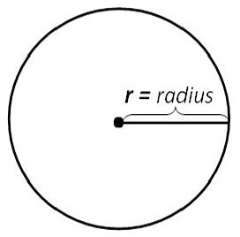
The next step is to draw buffer zones around our “public school” point features. Zgoba and colleagues studied residence restrictions at two different levels: first, a very severe restriction that banned sex offenders from living within 2500ft of a school, and second, a less severe restriction that banned sex offenders from living within 1000ft of a school. If you think about a 2500ft or 1000ft limit in every direction around a point, you should imagine a circle – the point in the middle is the public school, and the radius of the circle is 2500ft or 1000ft (whichever you have selected).

Let’s start with the 2500ft restriction. Drawing buffers is easy. Just go up to the Geoprocessing menu and select Buffer. A window like the one below will open up.

The Input Features option is asking you which features you want the buffers to be drawn around. In our case, that’s the schools – the proposed residence restriction would ban sex offenders from living within 2500ft of the school, so we need to know how much space that takes up around each school on our map.

Output Feature Class is asking you where you want to save the resulting shapefile that drawing the buffers will produce. This is nice because it means you are able to add the buffers to your map again at a later date without having to go through this process again.

Distance [value or field] is asking you how large the buffers should be. To the right of this field, you can see a drop-down menu where you can select the unit of measurement – miles, feet, etc. Our residence restriction in this case is 2500ft, so you can enter “2500” in the box and make sure the unit of measurement is set to feet.

Dissolve Type (optional) is, well, optional! It is just asking you if you want to merge the buffers that overlap, to make one big buffer polygon, or if you want to leave them all as individual circles. For this assignment I chose ALL, but it really is optional and not that important for our current task (it would be important if, say, you wanted to calculate the area within the buffer zone, without double-counting the overlapping areas).

Once you have filled out these settings, you can click OK and ArcGIS will draw the buffer zones around your public school point features.
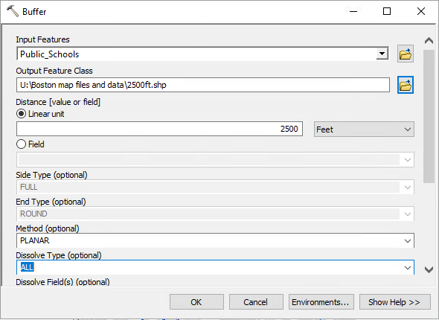

You should now have a base map with sex offender point features and school point features, and around all of your school point features, you should see large circles – the schools are at the center of each circle. The radius of each of these circles is 2500ft.

What do you notice about your map? How much of Boston is now covered by the buffer zones around your public schools? Are there any remaining areas where sex offenders could live? Make sure that your layer of sex offenders is “on top of” the buffer layer so you can see the point features – are there any sex offenders currently living in these 2500ft buffers? Remember, this is just public schools – we haven’t even considered parks, private schools, or daycares.

Drawing a 1000ft Buffer

2500ft was the most severe residence restriction that Zgoba and colleagues looked at. What about the 1000ft restriction? This should create smaller exclusionary zones around our public schools – maybe this will leave more available area for the registered sex offenders to find housing.

Go back to Geoprocessing Buffer and repeat the steps above to draw a new buffer, but this time make it 1000ft.

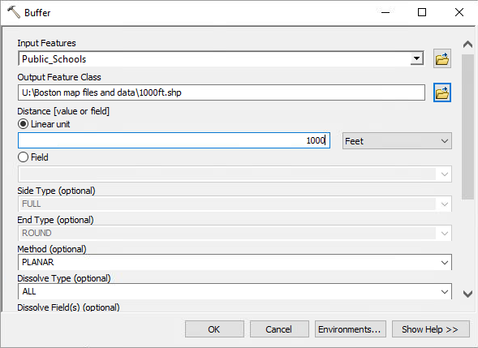
Click OK. The 1000ft buffers should appear as a new shapefile and layer in your Table of Contents. If you want, you can uncheck the box for the 2500ft buffer to hide it, as we’re not using it right now.

How is this buffer different from the 2500ft buffer? Does this leave more area for sex offenders to find housing? Do you see any sex offenders currently living in the 1000ft buffer zones? (Remember to make sure that your sex offender layer is on top of the buffer layer, or they will all be covered up!)

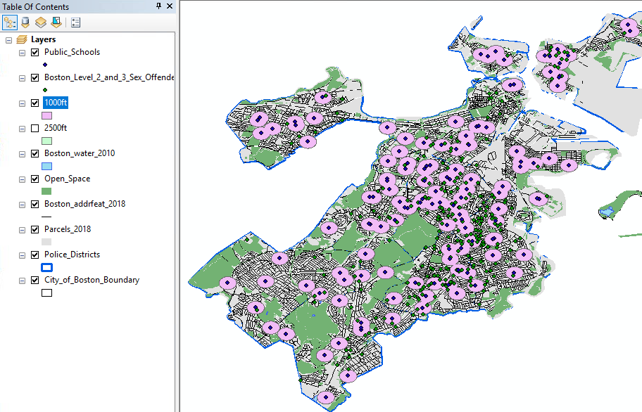

Who has to move? Using Select by Location

Now we can figure out who would be displaced if a residence restriction were implemented. We can already see that a 2500ft buffer would displace almost everyone, but what about the 1000ft buffer? What we can do is use Select by Location to select only those registered sex offenders who live within the 1000ft buffer zones.

Go up to the menu at the top of your screen and click Selections > Select by Location. We want to select features from our Boston Level 2 and 3 Sex Offender layer, and the source layer (which we use to limit the selection) is the 1000ft buffer layer. We want to select only the registered sex offenderswho are within the source layer feature – who are within the 1000ft buffer zone.

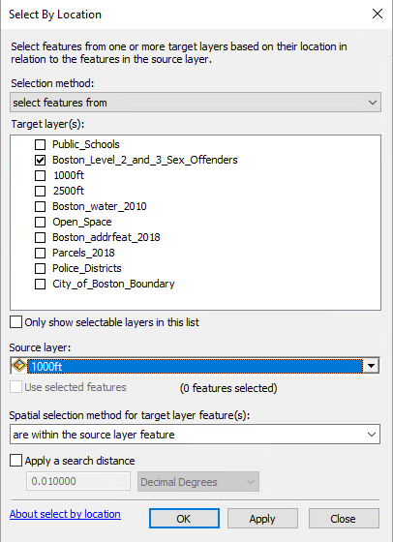

After clicking “apply,” you should see that the sex offenders within the buffer zones are now highlighted in light blue – this means they are selected. This allows you to do a quick visual check to make sure your selection worked (e.g. if you could see that all sex offenders are selected, when you only wanted those within the buffer zones, you would know something went wrong). If it looks good, click OK.
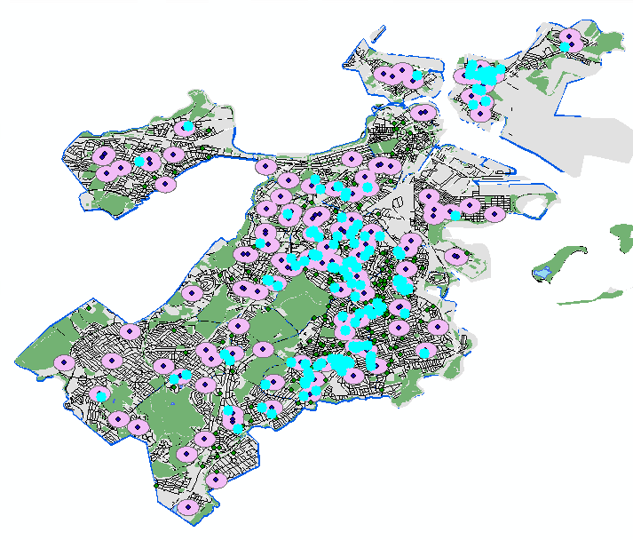
Generating a Report

With our selection made, we can now use the attribute table for the sex offender layer to generate a report of everyone who would be displaced if a 1000ft residence restriction for public schools was implemented in Boston.
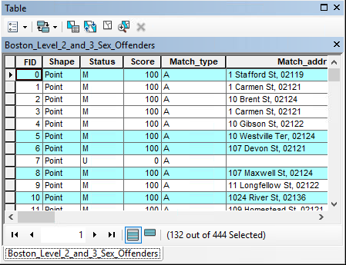
Right-click the sex offender layer in your Table of Contents to open the attribute table. You should see that some of the rows of the table (which correspond to individual sex offenders) are highlighted in blue – this is because they are selected, thanks to our Select by Location process. You should see 132 out of 444 sex offenders selected. This tells us that of the 444 sex offenders we put on our map, 132 are living within 1000ft of a public school – about 30%. Implementing a 1000ft residence restriction in Boston would mean that 132 sex offenders would need to find a new place to live, likely places that are more isolated, less accessible by public transport, and with less affordable housing!

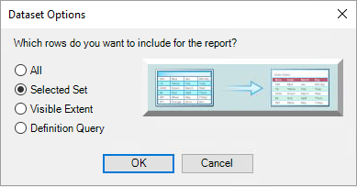
To create a list of all of the selected names, click the “Table Options” button in the top left corner of the attribute table, then scroll down and click Reports > Create Report. The Report Wizard window will open. The first thing to do is click Dataset Options… and select “Selected Set.” This will run our report on only our selected sex offenders – just the people living in that 1000ft buffer zone.

After you have selected “Selected Set,” click OK and then fill out the Report Wizard according to the screenshot below. The layer we want to include in our report is the Boston Level 2 and 3 Sex Offenders layer. From the “Available Fields” window, move Offender_N, STREET, and NEWZIP over to the “Report Fields” window. This will generate a report that includes the offender’s name, address, and zip code. Once you have filled this out, click Next.
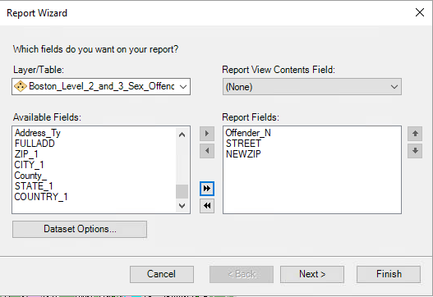

The next window asks if we want to group our report in any way (e.g. we could group it by the sex offender level of 2 or 3), but we’re not going to do that today so just click Next again.

The next window asks if we want to sort particular fields on our report, but we don’t, so click Next again.

For the question “How would you like to layout your report?” just leave the options on Stepped and Portrait.

You can now choose a style for your report. This is just cosmetic. For this assignment, I chose Chicago.

And finally, you can give your report a title. See the image below – I chose “Registered Sex Offenders Living Within 1000ft of Public School.” A long title, but anyone who picked up the report would know what it shows! Then you can click “Finish.”

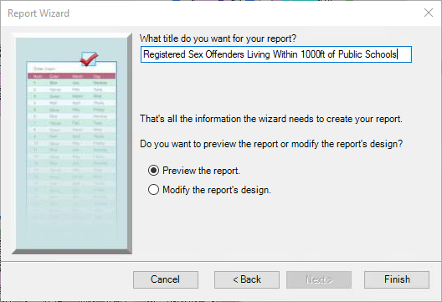

One thing I noticed when I first ran this report was that my title was too long for the font and page size. You can click the “Edit” button, select the title, and resize it to make it fit. Once you are satisfied, click the button with the green arrow (top left in the Report Designer window) to return to your report.

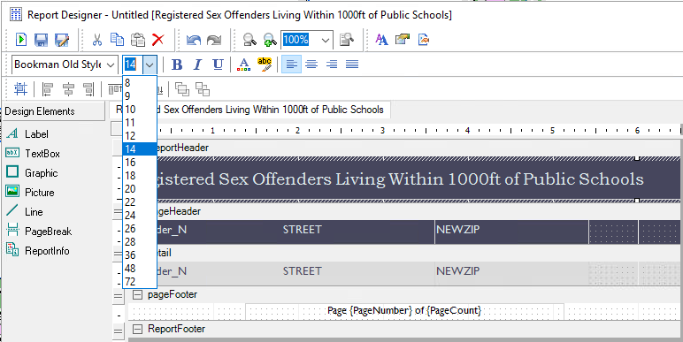

Finally, we can export our report as a PDF to share with others. The export report button is in the Report Viewer window, top left, near the two floppy-disk looking icons. It looks like a page with a green arrow and a little blue disk icon. Click this, and the Export Report window will open. Make your export format “Portable Document Format (PDF)” and then click the … button to choose where to save the PDF (ideally with all of your other mapping documents!).

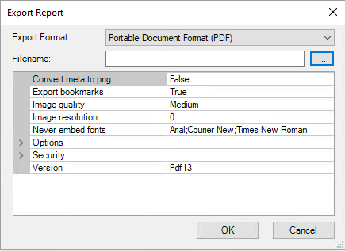

To complete this assignment, please export your map with the 1000ft buffer layer showing. Export the map as a JPEG. In the Blackboard dropbox, please upload your exported map JPEG and your PDF file for your report.

