Introduction to ArcGIS: ArcMap 10.5.1
Before we start: Downloading and storing data

Before starting, download the zipped file “Introductory Map Files” from Blackboard and unzip it into a new folder on your USB drive. I recommend calling this folder “Crime Mapping Map Files” or something else descriptive so you know what’s in there.
When you extract the introductory map files into your folder, you will see that there are many files with the same name but a different file type – for example, Boston_water_2010.prj, Boston_water_2010.sbn, Boston_water_2010.shp, and so on. There are six or seven files per map layer you draw, and all these files must be in the same folder for the map layer to work! Successfully using ArcMap means being very disciplined about storing your files correctly.
This is what my working directory for this class looks like:
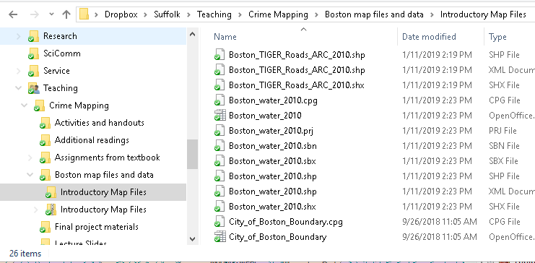

Opening ArcMap

You can find ArcMap in your start menu under the ArcGIS subfolder. Click Start, then ArcGIS, then scroll down until you see ArcMap 10.5.1. The icon looks like a globe with a magnifying glass. Click this to open the program. It may take a minute to open.
When you first open ArcMap, it will give you a window asking you if you want to open an existing map or create a new blank map. You can pick one of these options and click ‘Open’ or you can just click ‘Cancel’ to close the window and do whatever you want.
If you click ‘Cancel’ to close the window, your screen should look something like this:
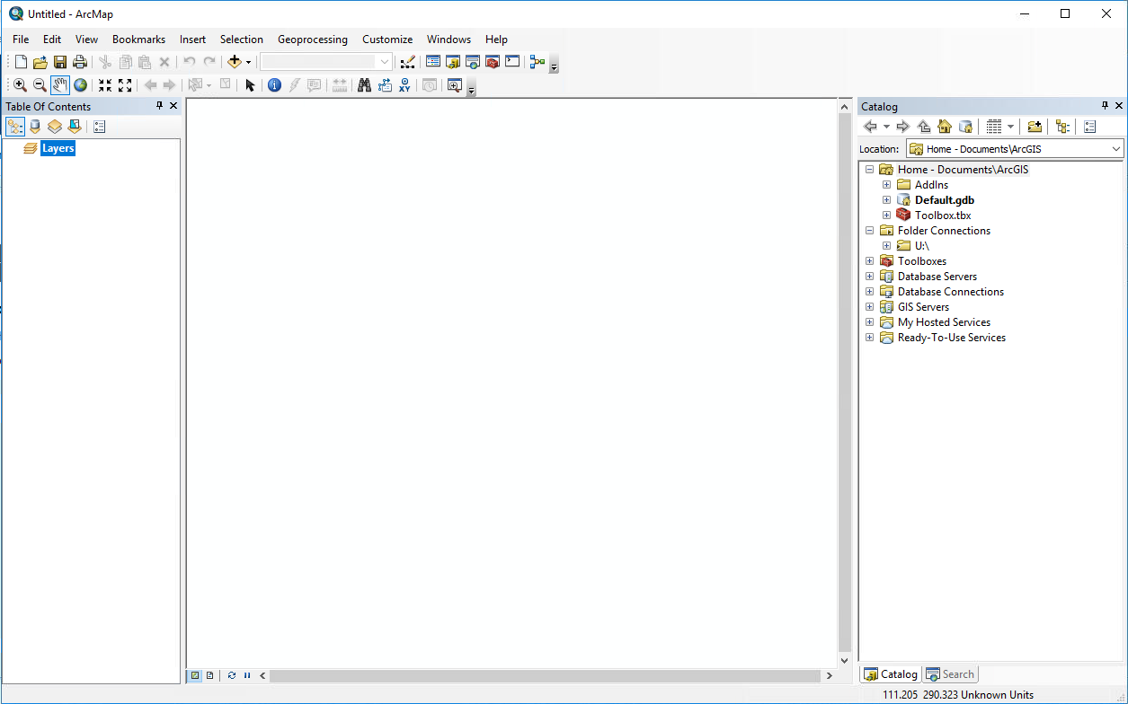
This is your basic ArcMap window. Across the top, you can see menus and toolbars, just like using most other programs (e.g. Microsoft Word). On the left, there is a frame that says “Table of Contents.” In the middle, the large blank area is your data frame – that’s where the map will appear. On the right, there is a frame titled “Catalog” – this is where you connect to different folders that store your data.
Views in ArcMap

At the bottom of the ArcMap window (below the data frame) there are two tiny little buttons. If you hover your mouse over them, one button will say “Data View” and one will say “Layout View.” When you want to edit your map, you need to be in Data View. This allows you to show/hide layers, find, select, and add different elements, and so on. When your map is finished and you are ready to turn it into a graphic for sharing, you will switch to Layout View to put your map in a frame and add elements like a scale, a north arrow, and a legend.
Data View (left) and
Layout View (right) buttons.

Connecting Your Working Folder to Catalog

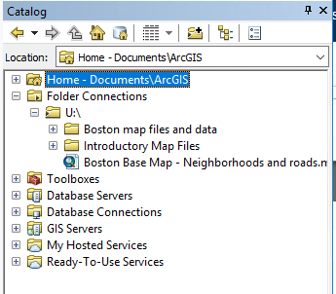
Whenever you want to start working in ArcMap, you will need to connect to your working directory (where your files are stored) through the Catalog. When you are working on your own computer, this connection is usually saved for you so you don’t have to do it every time. If you are working in a computer lab or through the Virtual Desktop, you might have to reconnect each time. Luckily, it’s easy.
To connect to your working directory, look at the Catalog and find the button that looks like a folder with a + on it. It is the third button from the right. When you hover over it with your mouse, it says “Connect to Folder.” Click the button, and then use the menu to navigate to your working directory. If you are using a USB drive, it is probably under “This Computer” and then you will see a USB storage drive. You can pick your crime mapping folder (where you saved those Introductory Map Files earlier!) and click OK. You should now see your working directory listed under the “Folder Connections” heading in your Catalog (see inset image – I connected my folder to my U: drive and can see my two other mapping folders in there).
The Table of Contents

The Table of Contents lists all of the data layers on the map and shows what the features in each layer represent. Right now, your Table of Contents should look empty because we don’t have any layers on our map yet, but we can change that!
There are two ways to add layers to a map. The first is to click the “Add Data” button. This button is on the first toolbar underneath all of the menu options. It is a yellow-ish diamond with a black plus sign on it. Using the Add Data button, you can navigate to wherever you saved your map files and add layers that way.
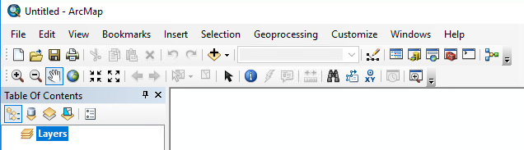
An easier way to add layers to your Table of Contents is to simply “drag and drop” them from your working directory (now connected to your Catalog) over to the Table of Contents frame. Try this now – look in your Catalog for your connected working directory and locate your Introductory Map Files folder. Even though you unzipped more than twenty files, you should see just four – these are the shapefiles (.shp) that can be added to your map. Click and drag “City_of_Boston_Boundary.shp” over to your Table of Contents and drop it there.
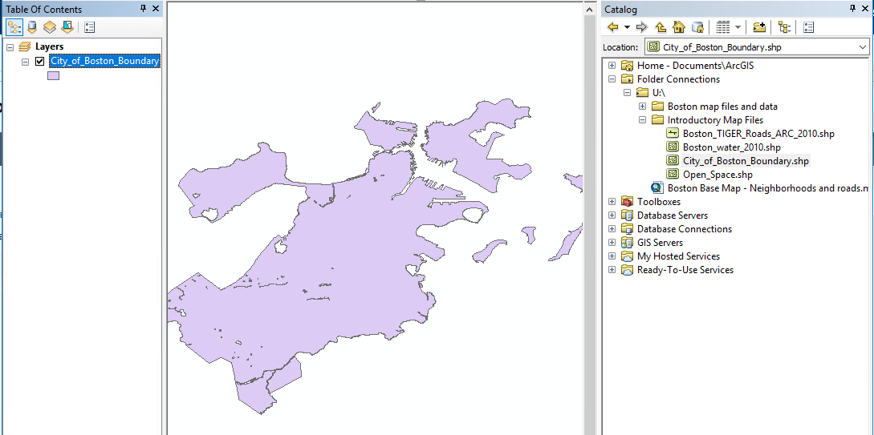
Look, a map! You have successfully added a layer of data to your map. This is an outline of the city of Boston. It might be a different color than mine – sometimes ArcGIS randomly picks colors for new layers. We will be talking a lot more about changing these colors and symbols in the next few weeks.
Rearranging Layers
Let’s add another layer – drag and drop the layer “Open_Space.shp” into your Table of Contents, below City_of_Boston_Boundary.
Do you see anything new on your map? Does it seem to match up to where you know you can find open spaces (like parks) in Boston?
Think of layers like pieces of paper. If you put a large piece of paper over a smaller piece of paper, it will hide the paper underneath. That is what is happening with our window – our big, solid shape (the whole city of Boston) is sitting on top of all of our little shapes (open spaces) and hiding them. You can change the order of layers by clicking and dragging them – drag your Open_Space layer above your City_of_Boston_Boundary layer and see if that looks better. Always remember this lesson when creating your maps – be intentional about the order of your layers! You will usually have your biggest layers on the bottom (city boundaries, large polygons) and more detailed layers on top (roads, buildings, points of interest).
Hiding and Showing Layers
Part of the art of mapping is knowing how much information you need to show, and sometimes you just don’t need to see all the layers on your map. You can show or hide layers in your Table of Contents by checking or unchecking the little box next to each layer’s name. Try this now – hide the Open_Space layer and then show it again.
Renaming Layers
You can see that our layers currently have the same name as their files, but this can look ugly. To rename a layer, you can click once on the layer name to select it, then click once more and it will become editable. Rename “Open_Space” to “Open Space” so it will look nice when we eventually make a legend for our map.
Removing Layers
You already know how to hide a layer, but if you want to remove it from your map altogether, just right-click it and select “Remove.” This will remove the layer from your map, but it will not delete the file.
Viewing Attribute Tables
For every feature that is drawn on your map – every line, point, or polygon – there is an underlying data matrix. You can view this data matrix by right-clicking any layer and selecting “Open Attribute Table.” This will open up the table window for that layer. For example, open the attribute table for the “Open Space” layer. You will see a large table – this table has 1012 rows, one for every open space drawn on the layer. In the column “SITE_NAME” you can see the name for each space. The column “OWNERSHIP” seems to tell us who is responsible for this space. Other columns tell the program how to draw this feature on the map. It is always useful to know what sort of data is included in a layer, because you can use this data to create labels, select features by attribute (e.g. select all open spaces owned by non-profits), and other data manipulations.
Toolbars

As you have probably noticed by now, there are a lot of different toolbars in ArcMap. Now we will learn what some of these buttons do. The first toolbar under the drop-down menus is the Standard Toolbar.

These buttons are probably pretty familiar – they perform most of the same functions as any other problem. The first button (the white sheet of paper) opens a new blank map. The second button (the folder) opens an existing project. The third button (the floppy disk) is the save button, and the last button (the printer) is the print button.

Further to the right on that same toolbar, you will find the undo and redo buttons (arrors), the “Add Data” button that we already explored, and a drop-down menu that shows the current map scale. There is also a button that looks like a pencil connecting some dots. This is the data editor button, which allows you to change the data underlying the map layers. We will not be doing much with the Editor tool in this class – we will edit our data in Excel or directly in the Attribute Table.
This is a useful set of tools. The first button is for your Table of Contents, in case you accidentally close it! The next button, which has a little yellow filing cabinet, is for the Catalog. Then there’s a button with a little globe – that’s ‘Search.’ Then a button with a red toolbox – this is the ArcToolbox, which we will use once we start geocoding, building address locators, drawing buffers, and making heatmaps. The button after that is for Python, which we won’t be using, and then finally the ModelBuilder, which we also won’t use in this class.
The next toolbar is the Tools toolbar. Descriptive, right?
The + and – magnifying glasses will zoom in and out on your map. You can also do this with your mouse wheel, if you have one.
The white hand is the Pan tool. Click this, then click and hold on your map. If you move your mouse around, the map will move around. Use this to move to the area of your map that you want to look at.
The globe icon is “Full Extent” – click this to zoom to a level that shows the entire extent of your current map. This can be useful if you accidentally zoom way too far out and can’t find your map. Not that that has ever happened to me…
The two buttons that look like arrows in a square are Fixed Zoom In and Fixed Zoom Out. They will zoom in or out on the center of your map.
The tool that looks like a white arrow over an aqua blue map is the Select Features tool.
The black pointer arrow is the Select Elements tool.
The blue circle with the i in the middle is the Identify tool. Try it out – click the Identify tool and then click one of the “open space” areas on your map. It will open up the Identify window and give you information about that map feature. What is the name of the open space that you picked?
Menus

Across the very top of the ArcMap window, you’ll see drop-down menus, just like most computer programs.

File contains options to create a new file, open a file, save/save as…, page and print setups, and other map sharing and export functions (more on this in a moment).

Edit is all the usual functions like cut, copy, paste, undo and redo.

View has another way to switch between Data View and Layout View (remember you can also use those tiny buttons at the bottom of the ArcMap window). You can also create graphs and reports from your map data (though in this class we will make our graphs in Excel and our reports in Word).

Selection has all the important selection options: by attributes, by location, and by graphics. We will use these in later assignments, but here’s a brief description –
Select by Attributes: allows you to select map features by some attribute. For example, select all open spaces operated by a non-profit, or select all offenses that involved a firearm.

Select by Location: allows you to select map features by their location in a given layer. For example, I could choose all offenses that happened within Boston Public Garden, or all sex offenders living within a given buffer feature drawn around Boston schools (which is exactly what we’ll do later this semester).

Select by Graphic: allows you to select features that intersect a graphic element. For example, I could draw a square around one area of Boston and then select all crimes that happened in just that square.

Geoprocessing has options that allow for managing and analyzing geographic data. You can find the ArcToolbox in here, as well as shortcuts for drawing buffers, merging data, etc.

Customize allows you to change which toolbars are shown at the top of your window. By default, you usually have the Standard and Tools toolbars, but at some point you may want to add others for quick access. If you ever accidentally move or delete a toolbar, you can find it again in this menu.

Window is a quick way to retrieve your Table of Contents or Catalog if you accidentally close them.
Saving Your Work

Saving maps in ArcMap is not as straightforward as saving other types of work. Remember all of those files behind every single layer of a map? All of those files are necessary for the map to display properly. When you just click ‘save’ in ArcMap, it will save your map but not the data displayed on it. This means that if you send that saved file to someone and they try to open it on their computer, it won’t work – the map won’t load without all of the data it needs to read. Oops!
So if you are saving a map just for you, you can just click ‘Save’ and save the map in your working directory with all of your other map files. It will remember that the map files are there and will access them when you next open the file. Map files saved this way save as .mxd. This file type can only be opened in ArcMap.
If you want to send the map to someone else so that they can open the file and work with it on their own computer, you will need to save your work as a map package, .mpk. To do this, go to File > Share As > Map Package and fill out the required fields. As you can imagine, these map packages can be very large files, because they save all of the data included in the map.
Finally, if you want to save your work to share with others but not have them edit the map in any way (for example, you want to share the map in a written report or a slide show, or print it to hand out), you can save your map as an image. To do this, you can switch to Layout View and use the + and – magnifying tools and the Pan tool (NOT the tools in the Layout toolbar -- use the tools on the Tools toolbar) to position your map in the layout, then go to File > Export Map… and save as a JPEG or PDF. We will learn more about creating attractive layouts and adding map elements like scales and north arrows in the upcoming weeks.
To submit your assignment maps on Blackboard, please use the Export Map… option and save as a JPEG or PDF. Do not upload a .mxd or .mpk package, as I won’t be able to view these without opening ArcGIS.

