WRITING ASSIGNMENT: APPLYING ROUTINE ACTIVITIES THEORY
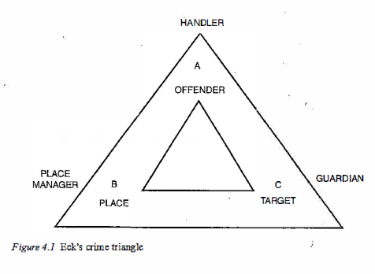
Your group has been assigned a number. For the crime problem with that number:
Identify the elements of the crime triangle: motivated offender, suitable target or victim, the place and time, and potential handlers, guardians, and managers.

Brainstorm: how to decrease offender motivation, decrease target/victim vulnerability, and decrease the place “attractiveness” to crime, and how to increase the influence of handlers, guardians, and place managers.
Be creative but realistic! Your team should type up a document with your results and submit the document by the end of class.
- A local community has been having trouble with its downtown area at night. Specifically, they are experiencing a problem with alcohol-related assaults. These incidents happen on the main street, which has lots of bars (some nice, some not-so-nice), and the problem is worst on weekend nights and around the time the bars close.

- The local mall has had a long-time problem with retail theft – mostly small, non-secured items like clothes, CDs, etc. The thefts seem to happen most frequently on weekday afternoons, around 3-5pm. The companies with stores in the mall are starting to complain about the losses.

- Not a crime, but a serious problem: a local street seems to have more than its fair share of pedestrians getting struck by cars! The street is a common cut-through between two other main streets and there is no clear signage for crosswalks or posted speed limits. It is a street with some housing, small businesses, and is located near schools, parks, and other recreational areas. The pedestrians injured are usually school-aged children or elderly people.

- There is an area in your town made up of several blocks of high-occupancy apartment buildings – like a housing project. The buildings are many stories tall and have lots of apartments in each, most of them rented (not owner-occupied). The area is struggling with an open-air drug market, which attracts buyers and sellers of illegal drugs and also comes with other associated crimes.

- There is a retail area made up of street-facing storefronts – a “strip mall” or “outdoor mall.” The outdoor mall has a large, uncovered parking lot. Lately the mall property managers have had a problem with thefts from visitors’ vehicles. Criminals have been breaking into cars and stealing valuables like wallets, GPS systems, etc. What can the property managers do to reduce thefts?

- A residential neighborhood has had a lot of break-ins recently. The neighborhood is in a nice area, with lots of single-family owner-occupied homes that have tall fences, lots of trees and bushes, and large yards (lots of distance between neighbors). Thieves are breaking in during daytime hours, from 9am until about 3pm. What can the residents do to reduce the likelihood of more break-ins?

