Using Mapping for Tactical Crime Analysis

Introduction

You are a crime analyst with the Boston Police Department. Recently there has been a series of commercial robberies that your colleagues believe may have been committed by the same person or group of people, judging by similarities in the type of business targeted, the days and times of the incidents, and the details of each crime (e.g. how the offender behaved, what was taken, witness reports).
You have been provided with a spreadsheet listing the six incidents your colleagues believe are part of this series of crimes. Your job is to map the incidents and to perform a tactical analysis to help your colleagues apprehend the offender(s).
To start, you should create a new map of Boston using the city boundary, ADDRFEAT, and open space layers. You should also download the Robbery Series spreadsheet from Blackboard and place it in the same folder as your other map layers.
Geocoding the Series

The first step in this process is to get your robbery incidents on your map. You have an Excel spreadsheet of addresses, so you will need to geocode the addresses to display them on your map.

Make sure you have downloaded the W10 Robbery Series spreadsheet from Blackboard and placed it in your working directory. From your Catalog in ArcMap, find the spreadsheet and add Sheet1$ to your Table of Contents. You can do this by dragging it over or by using the Add Data button.

Open the attribute table for the robbery series layer. What information do you have in this table? What can you tell just by looking at it – for example, what type of business are the offenders targeting? What hour of the day and day of the week seems to be the most likely time for incidents to occur? [Note: the day-of-week column numbers days 1-7, starting with Monday = 1; the hour column indicates the hour of the day using a 24-hour clock, so 0 = 12:00 (midnight) to 12:59am]

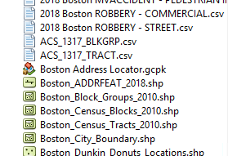
Let’s geocode these addresses. You should have a working Boston address locator in the “Dr Stone’s Map Layers and Data” folder you downloaded. When you look in this folder in your Catalog, the locator will look like a little house (see image on right)

Double-click this locator. It will open the Address Locator Manager and you should see your Boston Address Locator on the list. If you see it there, you can go ahead and click Close. It is ready for us to use.

Right-click your robbery series spreadsheet (which should be in your Table of Contents) and select Geocode Addresses… A window will open asking you which address locator you want to use, and you should select the Boston Address Locator and click OK. The geocoding wizard will open and you should fill it out by indicating that the street or intersection can be found in the ADDRESS column, the ZIP code is in the ZIP column, and you want to save your output file in your working directory as Robbery Series.shp.

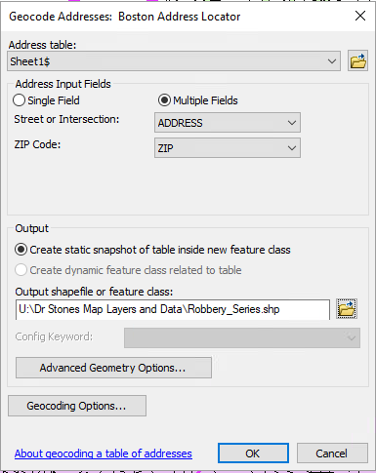

The addresses should be a 100% match (because I selected them just for you! You’re welcome), so you should not need to do any rematching.

You should now see the 6 robbery incidents on your map. They will likely appear as small circles by default. Change the symbol to a red and black bullseye, like this:

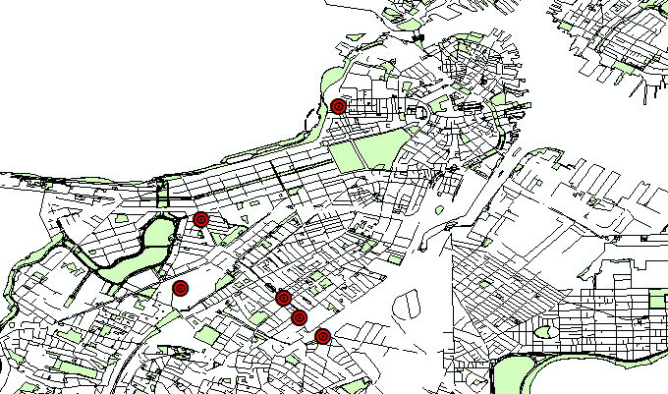

These are our robbery incidents. Do you see any sort of pattern at this point? Is there anything you can say about these incidents from this map alone? Probably not much.
Let’s see what order they happened in so we can start getting a sense of how our offender is selecting targets. Right-click on your geocoded robbery layer and select Properties and then the Labels tab.
Check the box that says “Label features in this layer.” Further down, where it says “Label Field,” use the dropdown menu to select “ID” – this is the column in our spreadsheet that had the number of the incident in the series. [Make sure you select ID, which is some way down the list, and not FID]. You should also increase the font size to about 18 so that you’ll be able to see your labels. Make the font bold, too. Click OK.
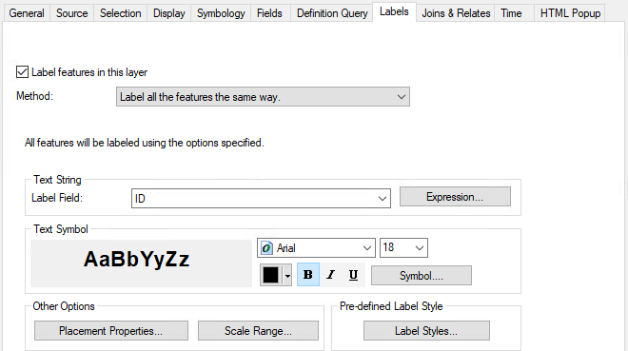

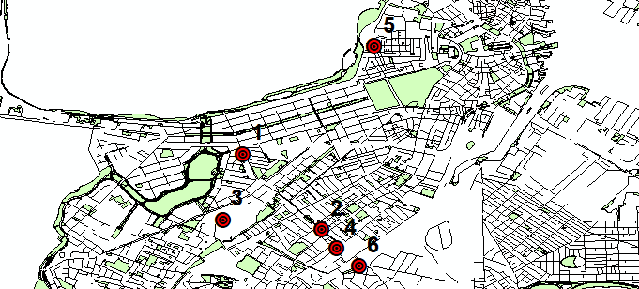
You should now see black numbers next to each point – this is the ID for each incident (taken from the ID column in the spreadsheet).
Predicting the Next Target

What can we learn from these incidents that will help us predict other likely targets for this offender? What can we learn that might help us narrow down where our offender lives (or at least where he starts his “journey to crime”)?
One of the most obvious things our data tells us is that the offender appears to be targeting Dunkin’ Donuts stores. This suggests that there’s something about these businesses that make them attractive targets to our offender. We don’t know what yet, but we can probably safely assume that the next robbery incident will also happen at a Dunkin’ Donuts. We should add Dunkin’ Donuts locations to our map.
How could you get a list of Dunkin’ Donuts locations?
The good news is that I’ve done it for you already! You can go to Blackboard and find the Dunkin’ Donuts shapefile in the Week 10 folder. Download this zipped folder and extract all the files inside to your working directory, then drag this layer to your Table of Contents. I changed my symbol for the Dunkin’ Donuts stores to pink squares, for obvious reasons.
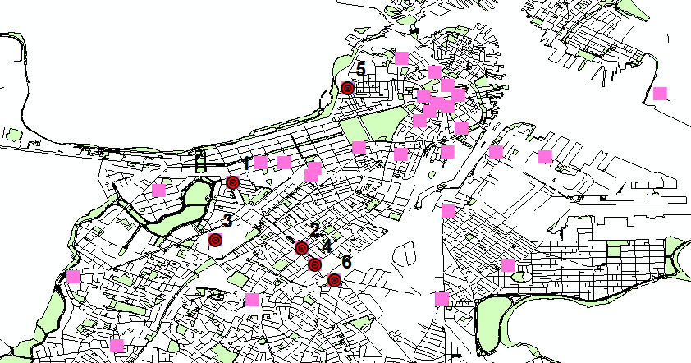
So now we have a lot of possible targets for our offender, but we need to narrow it down a bit more – this is too many stores for police officers to watch. How can we narrow down to the most likely targets?
One thing we can do is see how far apart our robbery incidents are from each other. This will help us narrow down a likely area where the next target will be located. It is unlikely that our robbery offender will suddenly break his pattern and travel a much longer distance to his next target. [Note: For this step it might help to turn off your ADDRFEAT layer so you don’t misclick! Just remember to turn it on again later.]
We will use the Measure tool to calculate the total distance between our points, then divide by the number of trips to get the average distance. Click the measure tool and a small window will open. First, click the Sum button so that it will tell us the total distance traveled. Then click the arrow next to the Sum button and select Distance Miles.
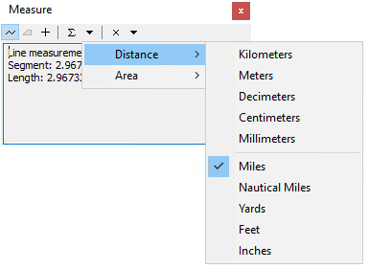
Using your Measure tool, click once on the first (1) crime incident. Then click on incident 2, 3, 4, and 5 (in order!), and finally double-click incident 6. Double-clicking will end your measurement. The Measure window should give you the sum (Sum Lengths) of the distance between your points, and it should be about 5.97 miles.
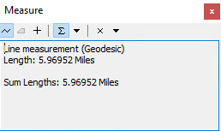
To get the average distance between each “hit” (incident), we need to divide this number by the number of trips made. This is the number of incidents (6) minus 1, because we don’t know the distance before the first incident (we know 1 2, 2 3, 3 4, 4 5, and 5 6, for a total of 5 trips). 5.97 divided by 5 = 1.19 miles. Our incidents are an average of 1.19 miles apart, so our next hit will most likely be within approximately 1.19 miles (no guarantees, but an educated guess is better than nothing!).

How can we tell which Dunkin’ Donuts locations are within 1.19 miles of our last incident?

I hope you guessed it – we draw a 1.19-mile buffer around the last incident in the series!
First, we want to select just our final incident and draw a buffer around that incident only, not every incident in the series. Open your attribute table for your Robbery Series layer. IMPORTANT: ArcMap has likely rearranged the incidents in the file. The FID (feature ID) is not the same as the ID indicating the order of the incidents. Make sure you scroll across the table to find the ID column.
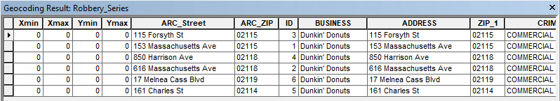
Incident 6, the final incident in the series. To select it, click the grey box at the beginning of the row.

When you select the row, it should turn light blue/teal. Once you have selected the correct row, you can close the attribute table.
Go up to the Geoprocessing… menu at the top of your screen and select Buffer. (You can also find this in ArcToolbox Analysis Tools Proximity Buffer.)
Your Input Features are your robberies – use the drop-down option to select the robbery series layer. Choose where to save your buffer output layer. I saved mine in my working directory as Robbery Buffer. Set the distance to 1.19 miles. Click OK.
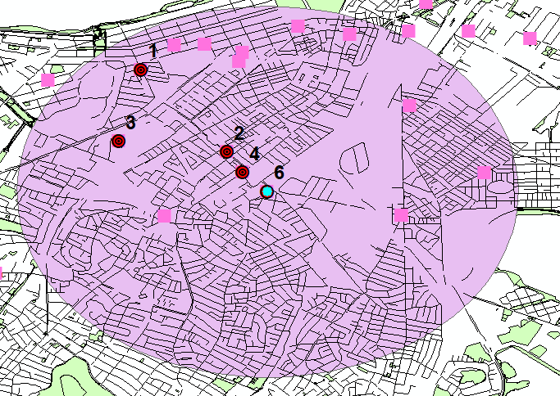

Narrowing Down

Our educated guess is that our next robbery incident will happen within this buffer. A quick “eyeball” count tells me that this gives us at least ten likely targets – that’s better than the 30+ we had before, but that’s still a lot of targets for our officers to watch. Can we narrow it even more?
It looks like our robbery incidents are a bit more tightly clustered than our buffer suggests – maybe our offender is familiar with this particular neighborhood. We can use our existing robbery incidents to calculate where most of the incidents are happening – we can illustrate this on our map by drawing standard deviation ellipses around our crime series. These ellipses allow us to see if there’s a particular direction to the events in our series – for example, should we focus on points running north and south of our incidents, or east and west?
First, make sure incident 6 is no longer selected – we want to use all incidents for this part of the analysis. Go to the Selection menu at the top of your screen and click Clear selected features.
Now open your ArcToolbox and go to Spatial Statistics Tools Measuring Geographic Distributions Direction Distribution (Standard Deviational Ellipse). Your Input Feature Class is your robbery layer. Save your output to your working directory as 1_SDE. By default, the Ellipse Size should be 1_STANDARD_DEVIATION. Click OK.
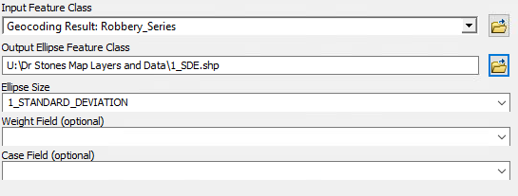
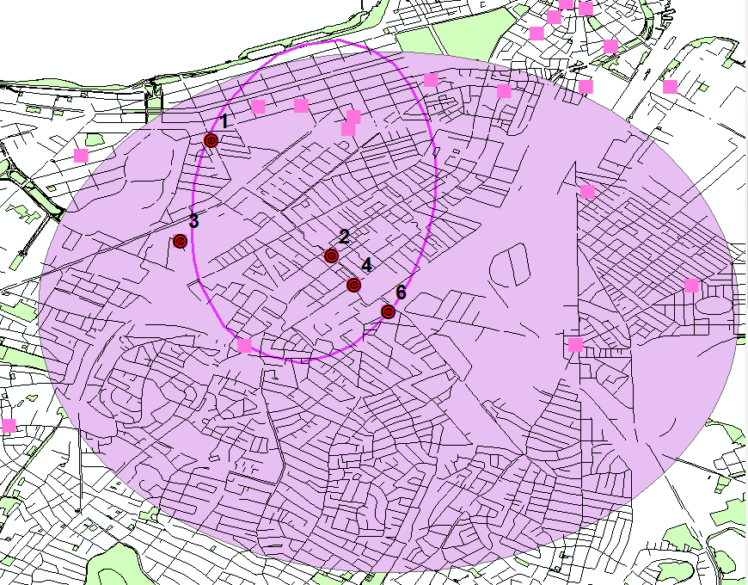
This narrows down our likely targets to a much smaller number of options! To make sure we cast a wide net, let’s add another ellipse that is two standard deviations – just to see if that includes any additional locations.
Repeat the steps above for your 1_SDE layer, but instead of 1_STANDARD_DEVIATION, change the ellipse size to 2_STANDARD_DEVIATIONS. And, of course, save your output as 2_SDE.
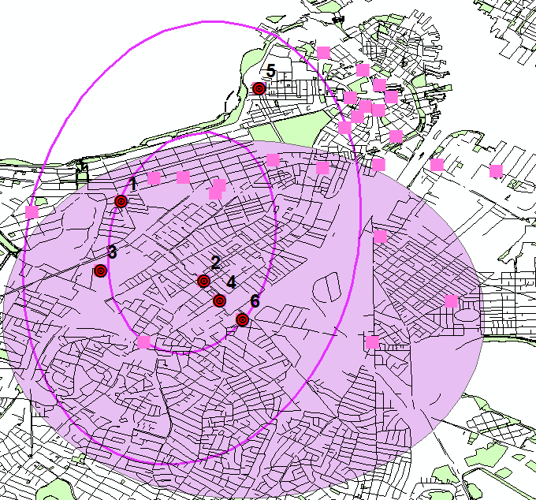
Hm, our 2_SDE ellipse doesn’t really capture that many more locations! Maybe 2-3 more, but at least one of those is outside of our original 1.19-mile buffer, so it seems a less likely target. We should probably focus on the 4-5 locations within both our 1_SDE ellipse and our buffer zone.
Sharing the Results

Finally, we should put our map into a professional layout and add some labels to help our colleagues know which locations they should watch. Switch over to Layout view. Switch your layout to the North American Letter (ANSI A) Landscape.mxd layout (see previous ArcGIS assignment if you forget how!). Add your title, legend, author information, scale, and north arrow.
It would be helpful if you added the addresses of the most likely targets so that officers don’t have to figure it out. Go to the Customize menu at the top of your page, then Toolbars Draw. The Draw toolbar should appear in your window.
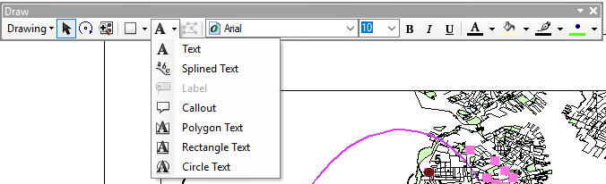
First, use the blue Identify tool (on your normal toolbar, not the Draw toolbar) to click one of the Dunkin’ Donuts locations inside the 1_SDE ellipse. I clicked the one closest to Incident 1 and it tells me that the address is 270 Newbury St.
On the Draw toolbar you will find a letter A with a down-arrow next to it. Click this and select Callout. Click near the 270 Newbury St location and drag your mouse out a little way, then release. This will create a “speech bubble”-style label for your map. Where it says ‘text’, write 270 Newbury St.
Do this for the four likely target locations (all located near Incident 1, in the north half of the 1_SDE ellipse). Make sure your labels don’t cover up any important map data.
Check the next page for what your completed map should look like. When you are happy with your map product, upload the JPEG (.jpg) file to Blackboard.

